Chapter 1: Introduction
  - Preamble
The project “Anti-Theft Library Management using Koha” will control the theft of books using the RFID tag. The application is related to books of library which is not issued or stolen . In this application, RFID tag will be used corresponding to each books to trace its various information.
RFID tag of the book is scanned by the RFID Scanner and all information(StudentID, BookID, RFID tag etc) is feed into the database of KOHA which is MYSQL based. Then the system information is redirected to the Apache Server. After this , Arduino is used to keep sensing the books RFID tag and generate a query to ask for the complete book details from the server to compare whether a particular book is issued or not . So, as the book that is not issued move through the gateway of the library premises an alram will be beeped indicating us about the book theft that has taken place .

  - Need of the Project
    - Providing convince to the system administrator to keep the track of books.
    - Radio frequency anti-theft is innovative and safe.
    - Security enhancement of library asserts .
    - Simplify patron check in/out.
    - Human resource reduction.

  - Problem Statement
At present the strategies used for management of libraries are not up to the mark. The process for finding a book, issuing, and arrangement is very cumbersome. Also very few libraries are equipped with the anti-theft technology. So, in this project we aim to semi-automate the functioning of library and also to provide a proper solution to ensure no theft in the premises.

  - Objectives
To develop a software which will aid in the automation of a library with few of the several other required functionalities:
- Book Availability
- Book Search,
- Proper Arrangement of books, and
- Anti-theft system.

  - Solution Approach
We will develop an application in Android which will have two broad catagory of users:
Solution for Students, Faculties:
- A Check Book Available option, that will enable the class of users to check for the availability of a certain book by quering it to our application.
- A Book Finder option, that will enable the users of this class to get the location of a book which will be queried by the user.
Solutions for Library Staff:
- An Issue Book option, which will let the staff to issue the book and update the record for the book issued in the library system.
- A Book Arrangement tool, which will help the user to place the book in the section which it correctly belongs to.

  - Organization of the Project Report
The report is organized in the following chapters:
Chapter 1 Describe the basic needs and objectives of the project and it also describes
scope and limitations of the project.
Chapter 2 Deals with background study and technical details.
Chapter 3 Deals with the feasibility study, functional and non-functional
requirements, hardware and software specifications.
Chapter 4 Focuses on the Design details. Architecture of the system is developed.
Chapter 5 Is the conclusion where a summary of the project is presented.

Chapter 2: Background
  - Current Scenario:
Bar Coding Technology:
One technology used for the identification is bar coding. A bar code provides the world's least expensive and most robust method of data entry. Although bar coding may not be directly linked to security monitoring, it is often seen as an equivalent comparison in terms of auto-identification. Auto-identification is the technology used to identify products, humans and animals. Even though RFID and bar coding come from the same technology family they are different in many ways.
For example, bar coding identification requires the line of sight to be read, meaning items can only be scanned one by one, and codes cannot be read if they happen to be damaged or dirty. This can be a time consuming task for the library clerk, especially in a busy store where customers can be waiting a considerable amount of time to be served. Bar code vendors have tried to come with some solutions to this problem. Thermal bar code printers and RFID printers can identify and correct bad bar codes before they enter the production or distribution system. The benefits of this kind of printing are improved accuracy and increased productivity. Such solutions are becoming more and more utilized in a variety of markets including healthcare, manufacturing and retail.
RFID eliminates this issue, as the chips embedded in the product allow multiple tags to be identified and processed simultaneously by the reader. What’s more, is that items can be oriented in any direction, as long as they are in the read range of the chip, direct line of sight is never required. As a result, RFID delivers a more rapid scanning time. It could therefore be possible for a full trolley of goods to be identified and processed simultaneously. This makes it immediately preferable over bar code identification in the majority of retail environments - where quick throughput of product is of paramount importance.
This leads us to the security benefits of RFID over barcode. RFID chips are very difficult to replicate. Data can be password protected, encrypted or include a 'kill' operation which can remove data permanently from the Electronic Product Code (EPC). The EPC is a product numbering system that uses a set of numbers similar to bar codes. It assigns each item with a unique product identification number. The EPC system can also be linked to a networked database which can be used to autonomously update and monitor information such as item destinations and the number of products in stock. This means that a product's path through a particular supply chain can be closely monitored and reviewed. Another security concern is that the RFID tags could be duplicated. If someone duplicates the tag, they could potentially produce a cloned tag that they could use. This is especially dangerous when you consider RFID chipped passports, or security cards used to access secure buildings.
Bar codes can only be used to identify the type of item, whereas RFID can identify specific items and even track their location. This means that RFID tags can hold information within them. A similar bar code technology exists in the form of two-dimensional bar codes, but this requires a bar code printer to print each piece of information. This can be expensive, time consuming, and requires a large space for the 2D bar code to be in the library. The book bar code is encoded both horizontally and vertically, allowing the amount of data encoded to be increased. On the other hand, RFID tags can contain a large amount of memory in a physically small space, particularly when the tag is passively powered.
A reason why RFID may not appeal to student is the price of the tags along with the additional equipment required for full implementation of an RFID system. Bar codes on the other hand, are a cheaper and more common (universal) solution for the identification of products. Although RFID tags would be more reliable, the cost is a factor deterring people from making the change from bar codes to RFID. Another reason that makes RFID superior is the same reason people are opposed to it. If something is tagged, the location of the object can be read Student are afraid that they or their possessions could be tracked by people, and do not want their privacy to be invaded in this way. Although this is not the reason for implementing RFID tags, it may consequently have an impact on the way the public conceive and interpret the concept of RFID for asset tracking.
RFID however, cannot be seen as a full replacement for bar coding. Both have their own advantages and disadvantages that vary depending upon the application in which they are used. For applications requiring reliable performance and re-usability (high-end products), RFID will prevail. However, in a system that requires reliable performance with low cost implementation (low-end products), bar codes will remain the clear choice for some years to come.

  - Work so Far:
- Current methods of preventing theft:
In the case of a theft, providing the magnetic strip hasn’t been removed from the book, when the book is taken out the door it should effectively pass through the security towers, which are essentially magnets, creating a magnetic field between them; this will disrupt the magnetic field and in effect, set off an alarm.
The benefit of this loud alarm, is a loud noise such as this draws attention and so not only by alerting the staff to the theft and security attention will go to this doorway, providing more witnesses to potentially identify the thief.
This alarm, depending on the quality of the system, will alert a main security control centre of which will communicate to the security guards on duty by radio communication in most cases of the theft, to begin the pursuit of the thief.
These are a few crucial points, from looking at today’s system in place, at which we think our RFID system improves on the system used today:
- RFID reader at library premises exit is discrete. It can be hidden at the exit and will cover the whole exit, ensuring there is no way of avoiding it.
- RFID chip, depending on librarian choice, can be discrete, i.e. thief cannot remove it.
- Product details are stored on the chip as the chip is activated.
- Faster read time of data on the RFID tag
- System informs security of book details - they are aware as to what they are looking for.
- Security is updated as to the products (the thief’s) movements throughout the centre.
Chapter 3: Analysis
  - Detailed Problem Statement
We are planning to use an RFID-based system, which will be controlled by an Apache based server embedded on either a Rasberry-Pi or an Audrino board. Every book will be assigned a unique RFID which can be detected using a RFID detector. This will help the students, faculties to check for the availability of a book, and also to get a location of a book which they are intrested to look for. With help of such an arrangement, we can ensure a proper anti-theft scheme in which, at the exit we will install a RFID detector tool, integerated on an R-Pi/Audrino Board which will check for the RFID going through the sensor, and if an unissued book is being carried it will generate an alarm to stop the theft.

  - Requirement Analysis

    - Functional Requirements

- Tagging –
Tagging is done through RFID tag by the librarian or patron . The corresponding RFID code will be updated in the database for further processing of various book details.

- Shelf Management–
The student as the primary user of the system select the book from the shelf of the library books which uses RFID to detect whether a book is taken or been kept at correct place on the shelf or not, If mistaken in the book arrangement the beep will heard notifying the misplace of the book to another shelf from its original position.

- Check In / Check Out-
The student who enter the premises of the library check in into the system with the help of there library identity card scanned. This would be helpful to maintain various information(date Of Visit, Card Number , Card Holder Name ,etc). Similarly , using the card the student may check out of the system when they are done with the issuing of books , reading newspaper from library ,etc.

- Anti-Theft Detection-
When the book is issued and moved out of the premises of the library the updated database is used by arduino to verify that the book moving out is being issued or not . If it is not issued then the beep will be heard. So, with this not issued book will never be able to move out of the premises this is how it detect the theft of any unissued book.

- Book Drop-
When the book is to be submitted again in the library so the book is drop at this area which change the RFID tag corresponding to each book to unissued and is again available to be issued from the library.

    - Non-Functional Requirements
- Reliability-
The readers are highly reliable . RFID library systems claim an almost 100 percent detection rate using RFID tags.
- High Speed-
A unique advantage of RFID systems is their ability to scan books on the shelves without tipping them out or removing them. A hand-held inventory reader can be moved rapidly across a shelf of books to read all of the unique identification information. Using wireless technology, it is possible not only to update the inventory, but also to identify items which are out of proper order.
- Long Tag Life-
RFID tags last longer than barcodes because nothing comes into contact with them. Most RFID vendors claim a minimum of 100,000 transactions before a tag may need to be replaced.

  - Feasibility Study
Considering the requirements, a full scale feasibility study was undertaken for testing the possibility of computerisation. The feasibility study was carried out under the following three areas :
- Technical Feasibility:
For software, it was thought to develop an in-house package and had a person with basic education in library and information science coupled with specialisation in computer programming and also familiar with library operations so that there can be a complete understanding of the requirements. This shows, that technically it is feasible to get the required hardware, software and a person having complete understanding of the requirements to develop the software package .
- Social Feasibility:
Generally computerisation brings fear of unemployment amongst the existing staff. The automation will not create unemployment problems but will create new job positions, like system manager, system analyst, programmers and programme maintenance staff, data entry operators, etc. It will also relieve the existing, professional staff from their routine clerical activities, so as to enable them to perform intellectual professional duties which will need reorganisation of staff. The reorganisation of professional staff will lead to job improvement as well as job satisfaction.
- Economic Feasibility:
The economic feasibility study was carried out under following areas : Cost of operations of existing systems Cost of operations of the proposed system Cost of development of the proposed systems Benefits of the proposed system. Cost of operations of the existing system : Financial records, like annual budget, payrolls, etc. were scrutinised and the librarian and each section incharge was interviewed to determine the manpower cost, material cost, operating cost, equipment cost, overhead cost, etc. for calculation of unit cost of each operations . Cost of operation of the proposed system: The computerised system requires manpower, materials, equipment, overhead cost, etc. Also, it requires data preparation and conversion cost, maintenance cost, site preparation cost, etc. Of the different cost requirements for the proposed system.

  - Diagrams

- Use Case Diagram :

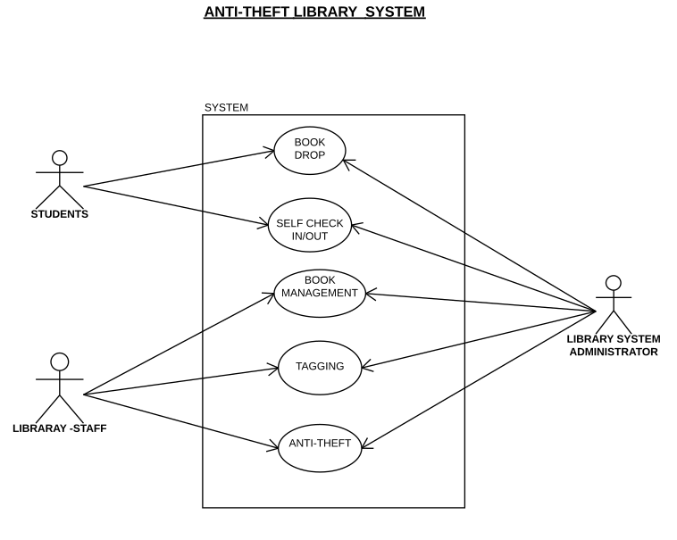
Fig 1 : The Use Case Diagram

- Activity Diagram

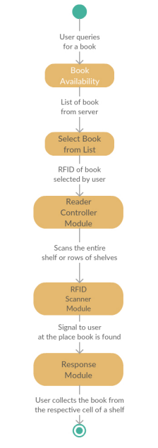
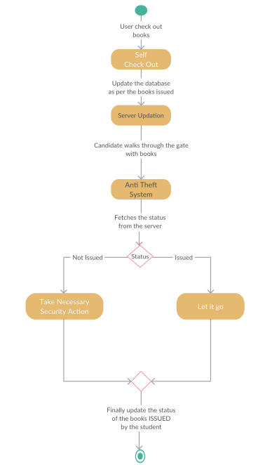

Fig 2 : Anti Theft Use Case Fig 3 : Book Search
Activity Diagram Activity Diagram

Chapter 4: Design
  - Architectural Diagram

- System Architecture Diagram
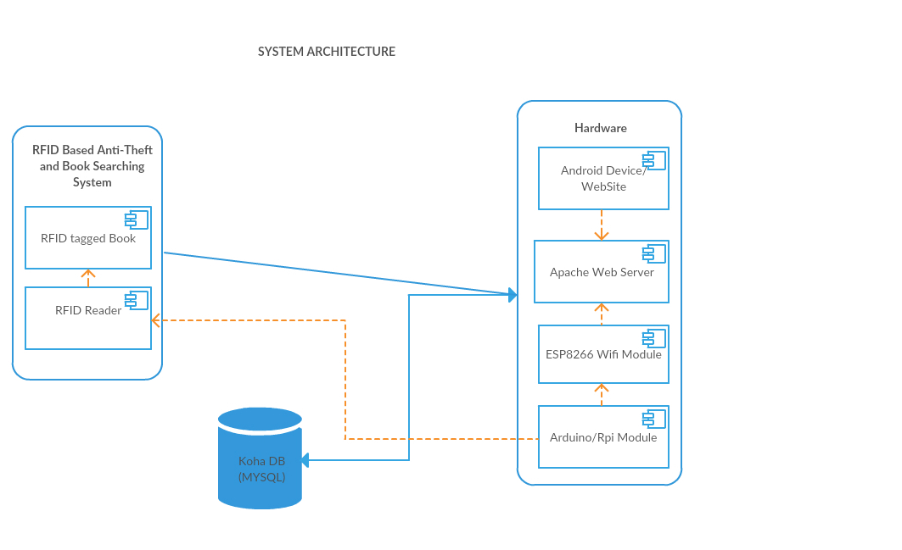

Fig 4 : System Architecture Diagram

- Structural Chart :
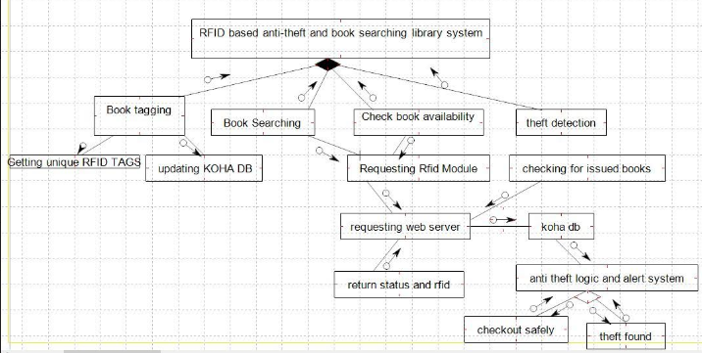
Fig 5 : System Structural Chart

  - Diagrams

- Data Flow Diagrams:
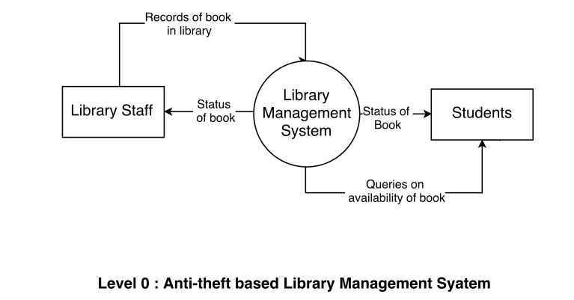
Fig 6 : DFD Level 0
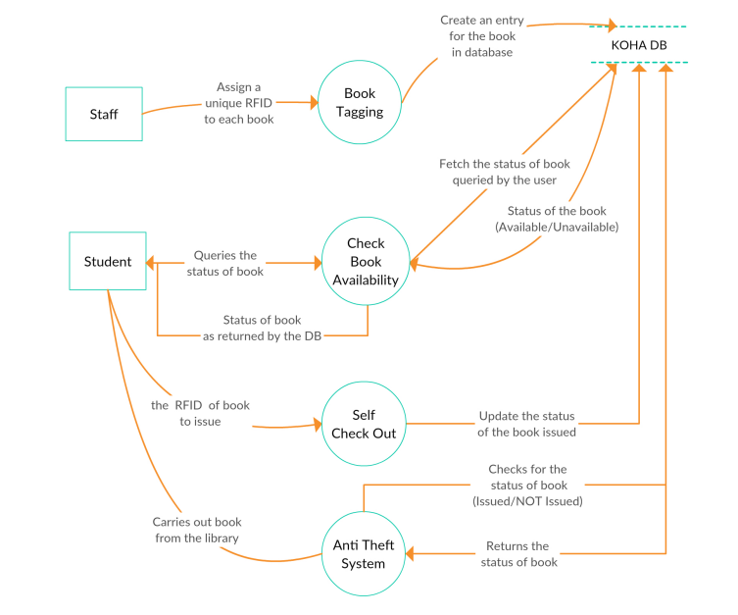
Fig 7 : DFD Level 1
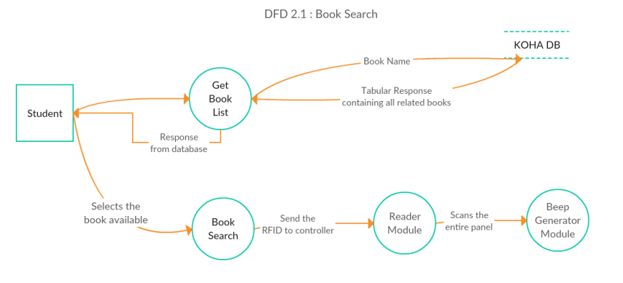
Fig 8 : DFD Level 2 – Book Search
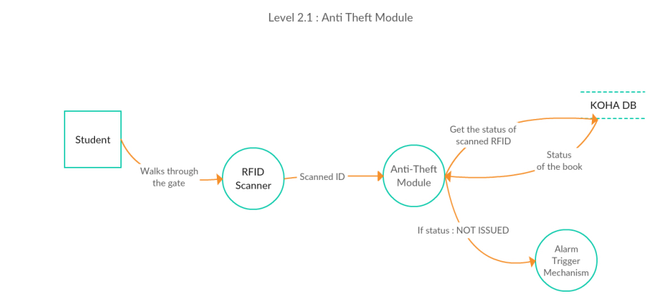
Fig 8 : DFD Level 2 – Anti Theft Module
- Sequemce Diagram :
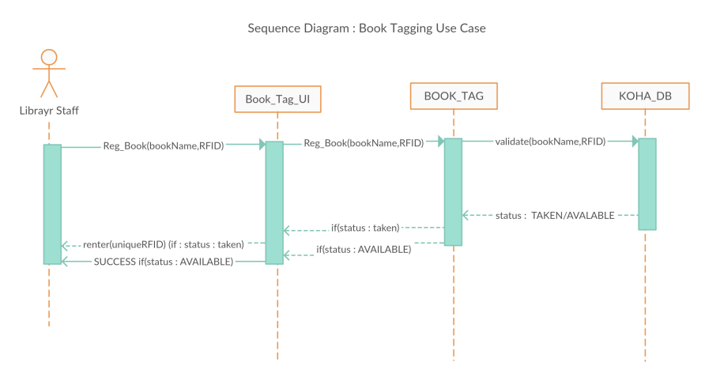

Fig 9 : Sequence Diagram – Book Tagging
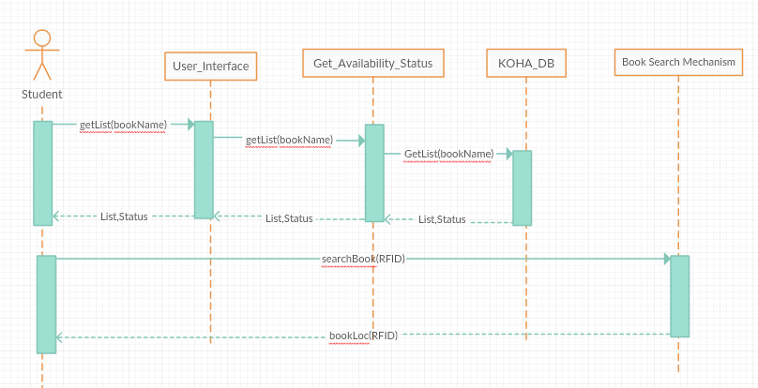
Fig 10 : Sequence Diagram – Book Searching
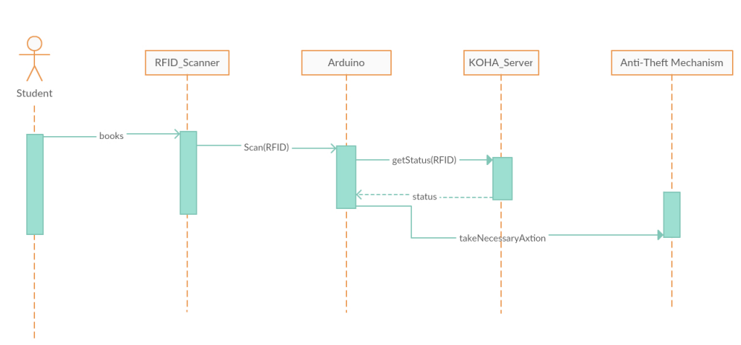
Fig 11 : Sequence Diagram – Anti Theft Mechanism

- Component Diagram
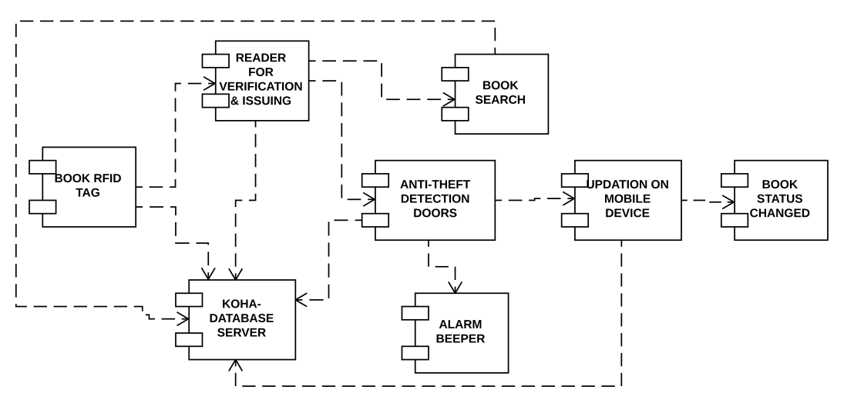
Fig 12 : Component Diagram for the system

- Deployement Diagram :
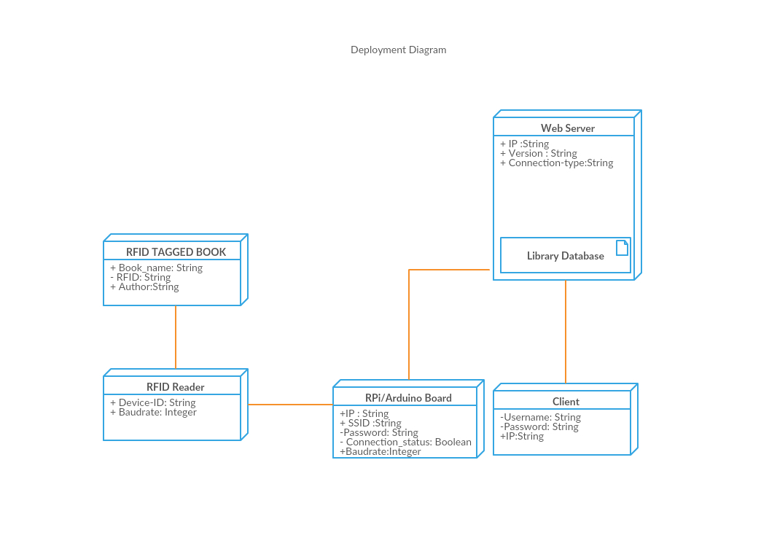
Fig 13 : Deployement Diagram for the system

Chapter 5: Conclusion
RFID technology promises to change our world. With RFID tags inventory related tasks can be done in a fraction of the time needed by bar code readers/scanners. Security is another aspect of library operations that may be greatly improved with RFID based security systems. Rather than purchasing additional tags for security, a single tag can be used for identifying items and securing them. As patrons leave the library, the tags are read to ensure that the item has been checked out. Librarians also report that lost or hidden items are more easily retrieved using the portable readers. Yes, RFID technology in the library speeds up book borrowing, monitoring, books searching processes and thus frees staff to do more user-service tasks.
The reality is that libraries are suffering from budget shortfalls as never before. With cuts to state and local governments, it is difficult for libraries to keep the library staffed and open. However, as mentioned the use of such technology will drastically reduce the cost of inventory control and shelf reading while enhancing the accuracy of inventory control and shelf reading and the fact that RFID is becoming increasingly prevalent as the price of the technology decreases.
References
- Youtube : https://www.youtube.com/watch?v=7nn3TGdIeIA
- Goggle: https://www.rfid-library.com/#
- Google: http://www.systemslibrarian.co.za/rfid.html
- Google: http://mosaic.cnfolio.com/B202Coursework2009C102

